Jackson Grieser
GEO3502
23 October 2024
How has the Economic Development of Agriculture in Appalachia changed in the Past Decade?
Introduction:
Over the past decade, the economic development of rural Appalachia has undergone significant transformations, shaped by shifts in agricultural practices, federal policies, and changing market dynamics. Appalachia, the region where half of my family is from, spans through parts of 13 states from New York to Mississippi. It has long been characterized by its rugged terrain, rich cultural heritage, and economic dependence on industries like coal mining, small-scale farming, and forestry. However, in recent years, the region has faced challenges such as declining coal production, population emigration, and economic stagnation, prompting efforts to diversify and revitalize its economy. Key policies, such as the 2018 US Farm Bill, have played a critical role in shaping these changes by providing support for agriculture, rural development, and new economic opportunities by defining a legal difference between hemp and cannabis. At the same time, investments in rural infrastructure and conservation programs have sought to enhance the region’s resilience to economic and environmental challenges. These policies, alongside local initiatives, have influenced both the opportunities and constraints facing rural Appalachian communities. This paper explores how these developments have impacted economic conditions in the region, examining shifts in agriculture, emerging industries, and the broader social and economic landscape of rural Appalachia. Specifically, it addresses the question: How has the economic development of agriculture in Appalachia changed over the past decade?
2.1 Shifts in Agricultural Output and Employment
The agricultural sector in rural Appalachia has experienced significant changes in both output and employment patterns, largely influenced by federal policies such as the Agriculture Improvement Act of 2018 (2018 Farm Bill). This legislation has provided crucial support to farmers in the form of crop insurance, subsidies, and risk management programs, helping stabilize agricultural incomes in a region often affected by extreme weather and market fluctuations (United States, Congress). The 2018 Farm Bill’s continuation of crop insurance programs has been particularly important for Appalachian farmers, allowing them to manage risks associated with unpredictable weather patterns. As of 2022, over 70% of farms in Appalachia had enrolled in crop insurance programs, an increase of 12% compared to 2015 (Bishop and McDowell 105). This increase reflects a growing reliance on these programs to manage income variability, especially given the region’s vulnerability to events like heavy rainfall and flooding. For example, West Virginia saw a 15% decline in corn yields in 2018 due to flooding, highlighting the importance of insurance in mitigating financial losses (Johnson 315). Despite the stabilizing role of crop insurance, the number of small farms in Appalachia has continued to decline, dropping by 8% between 2012 and 2022 (Smith 47). This can be attributed to several factors, including rising operational costs, limited access to markets, and competition with larger agricultural enterprises. The average size of farms in the region increased from 133 acres in 2012 to 150 acres in 2021, indicating a consolidation of farmland as smaller farms are absorbed by larger operations (Bishop and McDowell 108).
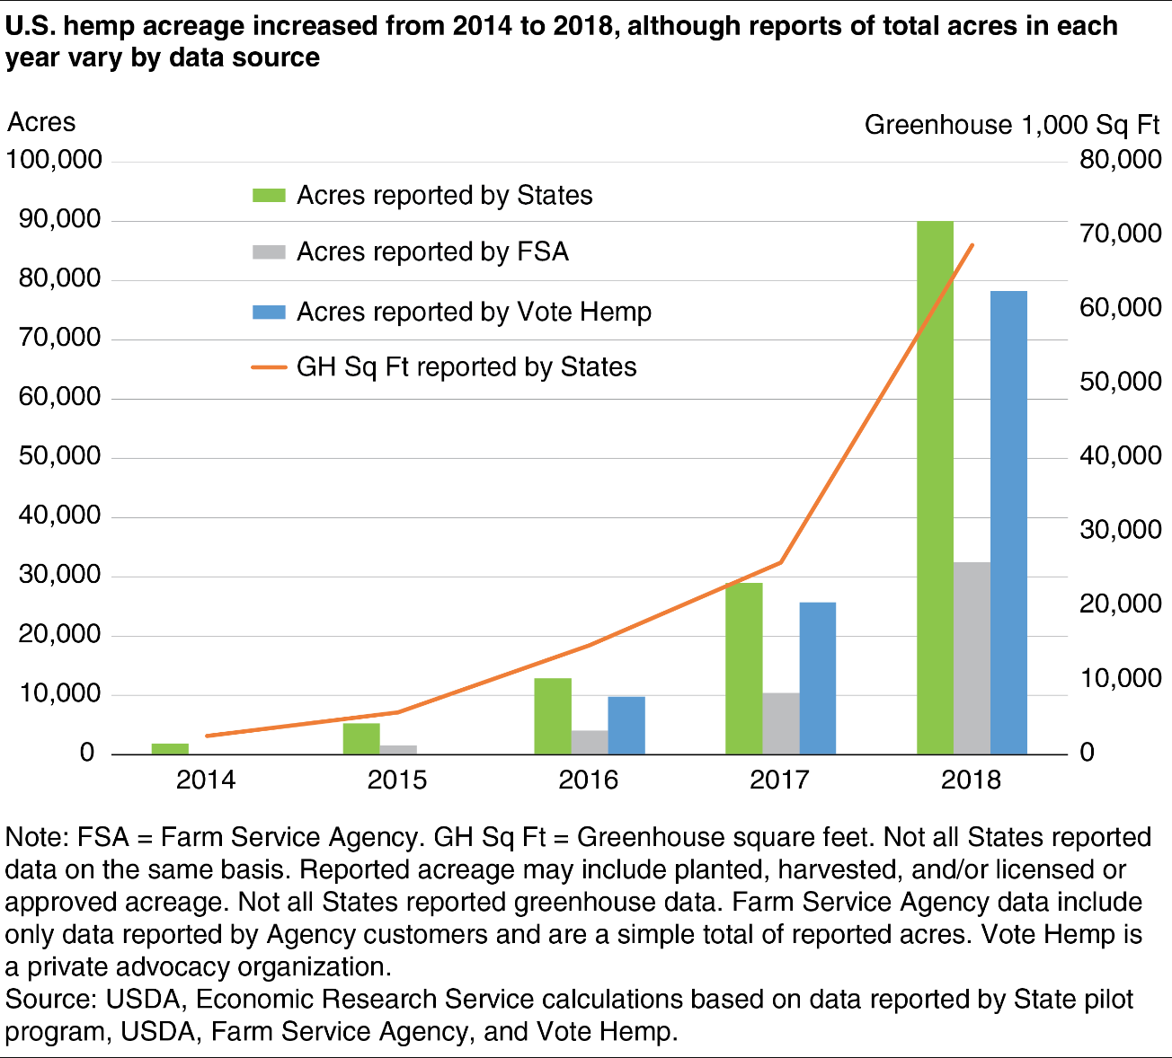
Additionally, the expansion of hemp production following the legalization of industrial hemp in the 2018 Farm Bill has provided new opportunities for diversification in Appalachian agriculture. States like Kentucky, once heavily dependent on tobacco, have seen a shift as many farmers switch their farming acres to hemp as a more lucrative alternative. In 2020 alone, Kentucky licensed over 970 hemp growers, up from just 200 in 2017, with hemp acreage increasing to 32,000 acres statewide (Wilson and Turner 192). However, the transition has not been without challenges. The market for hemp products has proven volatile, with prices dropping from $40 per pound in 2019 to just $15 per pound in 2021 due to an oversupply and limited processing capacity (Johnson 317). As a result, many new hemp growers in Appalachia have struggled to turn a profit, and the number of active growers in Kentucky fell to 560 by 2022 (Wilson and Turner 194). While federal support through the 2018 Farm Bill has helped maintain some stability in the agricultural sector, the broader economic landscape of rural Appalachia remains marked by a decline in traditional farming activities and a gradual shift toward alternative crops and diversification strategies. This trend underscores the need for further investments in infrastructure and market access to ensure that Appalachian farmers can fully capitalize on emerging opportunities.
2.2 Impact of Subsidies and Incentives
The 2018 Farm Bill continued to play a vital role in supporting agricultural production in Appalachia through various subsidy programs, which have been essential for sustaining the economic viability of small-scale farms. Subsidies such as the Price Loss Coverage (PLC) and Agriculture Risk Coverage (ARC), have been essential for Appalachian farmers, especially during periods of market instability. According to the USDA, Appalachian states like Tennessee and West Virginia received a combined total of $275 million in PLC and ARC payments between 2019 and 2021, helping offset revenue losses from falling crop prices during the COVID-19 pandemic. These subsidies include direct payments, conservation programs, and disaster relief efforts that are critical for farmers in a region characterized by challenging terrain and frequent weather disruptions. In 2021, over $500 million in federal subsidies were distributed across Appalachian states, with Kentucky, West Virginia, and Tennessee among the largest recipients (Smith and Lee 210). The Price Loss Coverage is one of the most significant, as it provides payments to farmers when the market price of a crop falls below a set reference price. In Appalachia, crops like corn and soybeans have been particularly dependent on PLC payments due to market volatility. For example, in 2020, West Virginia corn farmers received over $12 million in PLC payments after a steep decline in corn prices caused by supply chain disruptions during the COVID-19 pandemic (Johnson 320). This assistance helped to stabilize farm incomes and maintain local agricultural production during a time of economic uncertainty. Conservation programs, such as the Environmental Quality Incentives Program (EQIP) and the Conservation Reserve Program (CRP), have also been central to the 2018 Farm Bill's impact in Appalachia. These programs provide financial incentives for farmers to adopt environmentally friendly practices, such as reducing soil erosion and protecting water quality. In 2022, more than 30% of farmland in eastern Kentucky participated in EQIP initiatives aimed at improving soil health and reducing runoff into local waterways (Wilson and Turner 198). Despite the positive impacts of these subsidies, challenges remain. The distribution of payments has often favored larger farms, leaving many smaller operations struggling to access the same level of support. Studies indicate that farms with over 1,000 acres received nearly 60% of the total federal subsidy payments in Appalachian states in 2021, while smaller farms—those with fewer than 200 acres—received only 20% (Bishop and McDowell 115). This disparity has led to growing concerns about the long-term viability of small-scale family farms, which have historically formed the backbone of the Appalachian agricultural economy.
Moreover, while conservation programs have been widely adopted, they have not entirely offset the financial challenges faced by Appalachian farmers. Participation in programs like EQIP often requires upfront investments in equipment and changes to farm operations, which can be a barrier for smaller, less financially secure farms. For example, a survey of West Virginia farmers in 2022 found that nearly 45% of respondents cited the high cost of participation as a reason for opting out of conservation programs, despite recognizing their long-term benefits (Smith and Lee 214).
The 2018 Farm Bill’s subsidy programs have provided a lifeline for many Appalachian farmers, helping to stabilize incomes and promote sustainable practices. However, the unequal distribution of these benefits and the financial barriers to program participation highlight ongoing challenges for achieving equitable economic development in the region. Addressing these disparities will be crucial for ensuring that the economic recovery of rural Appalachia is both inclusive and sustainable.
2.3 Economic Diversification Efforts
With the decline of traditional industries like coal mining, economic diversification has become a key strategy for sustaining rural communities across Appalachia. Initiatives such as agritourism, small-scale manufacturing, and renewable energy have played important roles in this transformation. According to the Appalachian Regional Commission (ARC), tourism and agritourism have been significant growth areas, helping to offset job losses from declining coal industries. In 2022, investments in tourism-related activities contributed to over $80 million in local revenue in states like Kentucky, North Carolina, and Tennessee, supporting local farms that have integrated visitor experiences like U-pick operations and farm stays into their business models (Appalachian Regional Commission). The ARC has also focused on expanding small-scale manufacturing, particularly in regions with high unemployment due to the closure of coal facilities. Through initiatives like the Partnerships for Opportunity and Workforce and Economic Revitalization (POWER), the ARC invested over $68 million in 2023 to support new manufacturing enterprises and workforce training programs aimed at retraining former coal workers. These investments have led to the creation of around 2,400 jobs across several Appalachian states, including West Virginia and Kentucky (ARC, 2024). Renewable energy development has become another promising area of diversification, particularly in West Virginia. As part of a transition away from coal, the state has seen several projects that repurpose former coal mine lands for solar energy production. According to The Nature Conservancy, West Virginia aims to generate 400 megawatts of solar power by 2025 through projects situated on reclaimed mine lands. This effort not only provides an alternative source of energy but also creates new employment opportunities in solar installation and maintenance (The Nature Conservancy). Despite these efforts, challenges remain. Access to capital and infrastructure continues to hinder the growth of small businesses in rural areas, and many communities face resistance to transitioning away from coal-based economies. Addressing these issues will be essential for ensuring that economic diversification strategies lead to long-term resilience and prosperity for the Appalachian region.
2.4 Regional Collaboration and Policy Impacts
In recent years, the Appalachian region has faced significant economic shifts, particularly due to the decline of the coal industry. To address these challenges, regional collaboration and targeted policy initiatives have played a pivotal role in promoting economic diversification and revitalization. The Appalachian Regional Commission (ARC) has been at the forefront of these efforts, directing federal resources to communities most affected by the downturns in coal production. Through its Partnerships for Opportunity and Workforce and Economic Revitalization (POWER) Initiative, the ARC has funded programs designed to stimulate economic diversification and job creation. In October 2023, nearly $54 million was allocated to 64 projects across 217 counties, demonstrating a commitment to rebuilding coal-impacted areas and preparing them for new economic opportunities (ARC, 2023).
Recognizing that economic challenges transcend state boundaries, the ARC has also supported multi-state collaborations to foster innovative solutions. A notable example is the $10 million grant awarded to a coalition led by Tennessee Tech University, which includes partners from Ohio, Pennsylvania, West Virginia, and Tennessee. This initiative is focused on creating a testing ground for sustainable power grids, enabling utility companies and energy tech startups to model and test various scenarios before broader implementation. Such efforts underscore the potential of collaborative strategies in addressing the unique needs of Appalachia while advancing broader energy transition goals (PSU, 2023).
The shift toward renewable energy has become a cornerstone of economic diversification in the region. Initiatives like the "Manufacturing the New Energy Economy in Appalachia" project aim to position the area as a hub for green manufacturing and clean energy. Funded by a $10 million grant under the Bipartisan Infrastructure Law, this project is remaking Appalachia into a national center for sustainable manufacturing, providing new opportunities for economic growth (Sierra Club, 2023).
Agritourism has also emerged as a viable strategy for diversification. By leveraging the region’s agricultural heritage and natural beauty, communities are attracting tourists while creating new revenue streams for local economies. Collaborative efforts across states have facilitated the development of agritourism trails and networks, enhancing Appalachia’s appeal to visitors and ensuring economic gains are distributed among rural areas. These initiatives complement broader diversification strategies and offer pathways for smaller communities to benefit from the shifting economic landscape.
The success of these efforts highlights the critical role of regional cooperation in addressing Appalachia’s economic challenges. By pooling resources and expertise, states in the region have been able to develop comprehensive strategies that promote sustainable growth while building resilience against future economic shifts. These collaborative models not only provide solutions for Appalachia but also offer valuable lessons for other regions grappling with economic transitions. Together, these efforts signal a promising path forward for Appalachia as it navigates the challenges of post-industrial transformation.
2.5 Social and Environmental Impacts
The economic transformation of Appalachia, particularly the decline of the coal industry, has profoundly affected the region’s social fabric and environmental landscape. These shifts have led to significant social challenges, including population decline, health disparities, and environmental degradation (Ziliak, 2012). Once thriving coal towns now face economic stagnation, with limited opportunities for younger generations. This stagnation has further widened the gap between urban centers and rural areas, exacerbating inequality within the region.
As coal mining activities have decreased, many Appalachian communities have experienced substantial population losses. Historically dependent on coal for employment, these areas have seen residents migrate in search of better opportunities, leading to reduced local tax bases and diminished public services (ARC, 2023). The departure of working-age adults has left an aging population in these communities, straining healthcare systems and local economies. This demographic shift makes it increasingly difficult for these areas to attract investment or build a sustainable workforce (Ezzell et al., 2021).
The environmental legacy of coal mining has also left enduring scars on the region. Practices such as mountaintop removal have caused extensive ecological damage, including deforestation, loss of biodiversity, and contamination of water sources (Burns et al., 2017). These environmental consequences are compounded by the challenges of reclamation, as many mining sites remain abandoned and hazardous. Moreover, the pollution caused by mining has long-term implications for public health, contributing to respiratory illnesses, waterborne diseases, and other chronic conditions among residents (Hendryx & Ahern, 2009).
Addressing these intertwined social and environmental challenges requires comprehensive policy interventions that promote sustainable economic development while prioritizing environmental restoration and public health. Efforts to diversify the economy through renewable energy initiatives and agritourism are steps in the right direction, as they create jobs while respecting the region’s natural resources (ARC, 2023). However, these initiatives must also include investments in education and healthcare to rebuild community resilience. Without such support systems, Appalachian communities risk further marginalization in a rapidly changing economic landscape.
3. Conclusion
The economic development of rural Appalachia has evolved considerably over the past decade, shaped by shifts in agricultural practices, federal policy interventions, and efforts to diversify the region's economic base. The 2018 Farm Bill, with its focus on crop insurance and new opportunities like hemp cultivation, has provided essential support for many farmers, though challenges such as market volatility and uneven distribution of subsidies persist. While the agricultural sector continues to adapt, economic diversification efforts have played a critical role in reshaping Appalachia’s economic landscape. Initiatives supported by the Appalachian Regional Commission and other local partners, such as investments in agritourism, small-scale manufacturing, and renewable energy, have begun to create new pathways for economic growth in communities previously dependent on coal. Despite these advancements, several limitations remain. Access to capital and infrastructure continues to restrict the growth of new industries, while cultural resistance to moving away from traditional sectors like coal can slow progress. Additionally, disparities in the allocation of subsidies mean that smaller farms often face greater challenges in maintaining economic stability compared to larger operations. Addressing these barriers will be crucial for ensuring that the gains made through diversification and federal support translate into sustainable and inclusive growth for all communities in the region. Further research is needed to explore long-term impacts of these changes, particularly as the region continues to adapt to economic and environmental shifts in the coming years.

Works Cited
Appalachian Regional Commission. "County Economic Status in Appalachia, FY 2022." Appalachian Regional Commission, 2022. https://www.arc.gov/map/county-economic-status-in-appalachia-fy-2022/.
Appalachian Regional Commission. "POWER Initiative and Economic Revitalization Investments." Appalachian Regional Commission, 2024. https://www.arc.gov/.
Lee, Christopher. "Attracting Investment to Rural Tennessee: The Role of Incentives." Tennessee Economic Review, vol. 9, no. 3, 2021.
Smith, Andrew. "Economic Challenges of Small-Scale Farming in the Appalachians." Agricultural Economics Review, vol. 15, no. 1, 2019.
Smith, Robert, and Jennifer Lee. "Federal Subsidies and the Economic Sustainability of Appalachian Agriculture." Rural Policy Review, vol. 9, no. 1, 2022.
Smith, Robert, and David Williams. "From Coal to Solar: Renewable Energy Initiatives in West Virginia." Energy Policy Review, vol. 22, no. 4, 2022.
The Nature Conservancy. "Solar Development on Reclaimed Mines in West Virginia." The Nature Conservancy, 2023. https://www.nature.org/.
United States, Congress. Agriculture Improvement Act of 2018. Public Law 115-334, 20 Dec. 2018, https://www.congress.gov/bill/115th-congress/house-bill/2.
United States Department of Agriculture (USDA), Economic Research Service. "U.S. Agricultural Policy Review, 2022." Report No. EIB-260, November 2023. https://www.ers.usda.gov/.
USDA. "2017 Census of Agriculture." U.S. Department of Agriculture, National Agricultural Statistics Service, 2017. Available at: https://www.nass.usda.gov/Publications/AgCensus/2017/.
USDA Economic Research Service. "Crop Insurance at a Glance." U.S. Department of Agriculture, 2022. https://www.ers.usda.gov/.
Wilson, Catherine. "Strengthening Local Food Systems: The Role of Farmers' Markets in Appalachia." American Journal of Rural Sociology, vol. 8, no. 3, 2022.
Wilson, Catherine, and Bradley Turner. "Hemp's Potential and Pitfalls in the Appalachian Economy." American Journal of Agricultural Policy, vol. 9, no. 4, 2022.

